

Upgrading Replication from SQL Server 2000 32-Bit to SQL Server 2008 64-Bit
SQL Server Technical Article

Author: Alexei Khalyako

Contributors: Dmitry Artemov, Sergey Pyrin

Technical Reviewers: Vijay Tandra Sistla, Mike Weiner, Mark Souza

Editor: Beth Inghram

Contents
Introduction 3
Publisher and Distributor on Stand-Alone Servers 3
Publisher and Distributor on a Windows Server 2003 x64 Cluster 11
Conclusion 12

Introduction

This article summarizes the experiences we gathered during the planning and upgrade of a customer’s project. The customer is one of the largest retail shops in its area. Their architecture is made up of a main server, which is located at headquarters and hosts several hundred publications containing over a thousand articles. Regional stores are located all over the country acting as subscribers for the publications hosted on the main server. Based on the business needs and infrastructure limitations the customer set the following goals for the project:
- Install all SQL Server instances on the Windows Server® 2003 x64 platform.
- Upgrade the publisher and distributor from the 32-bit edition of SQL Server 2000 to the 64-bit edition of SQL Server 2008. (Upgrading subscribers was not a goal of this phase of the project.)
- Avoid replication re-initialization.
This paper describes how to upgrade replication members such as Publishers and Distributors from the 32-bit edition of SQL Server 2000 to the 64-bit edition of SQL Server 2008. Both clustered and nonclustered environments are discussed.
The main idea of the approach discusses here is the following: If it is not possible to do an in-place upgrade (which is the simplest and often preferable way to move to SQL Server 2008), and if your organization cannot afford to do a parallel setup to upgrade side by side (for example, due to limitations imposed by application architecture, infrastructure limitations, or something else), you can upgrade system databases on an external lab installation and later use them to create new production installation with exactly the same settings and objects as you would use for an in place upgrade. Of note, utilizing virtual machines may also be a good fit particularly if you are upgrading a number of servers. You may also be able to take advantage of some of the “undo” functionality of virtual machines to easily create and destroy instances of SQL Server.

Publisher and Distributor on Stand-Alone Servers

Migrating stand-alone servers is a straightforward process. It consists of the following important phases:
- Execute an in-place upgrade from the 32-bit edition of SQL Server 2000 to the 32-bit edition of SQL Server 2008 (known as an intermediate installation).

Note: In order to migrate directly from SQL Server 2000 to SQL Server 2008, your database instance must be first upgraded to SQL Server 2000 with service pack 4 (SP4).

- Check to confirm there are no transactions left to replicate.
You may have several databases in your instance SQL Server that are involved in replication. Querying the table sys.sysdatabases will help you determine which databases on your instance are part of the replication configuration. Then you can check to see whether any transactions in the transaction logs of the databases marked for replication.
This query returns the list of databases.

SELECT NAME from master..sysdatabases where category in (1,2,4,8)

----
Name
AdventureWorks

In this example, only the AdventureWorks database is involved in replication. In this case, you can run the following statement to return pending transactions for replication.

USE AdventureWorks
GO
EXEC sp_repltrans
GO

An empty output indicates that there are no pending transactions.
- Back up the master, msdb, distribution, and user-replicated databases.
- Uninstall the SQL Server 2008 intermediate installation.
- Perform a final, fresh installation of the 64-bit edition of SQL Server 2008.
- Restore the master, msdb, distribution, and user databases. It is possible to use detach and attach operations to upgrade user databases; however, master, msdb, and model databases created in SQL Server 2000 or SQL Server 2005 cannot be attached in SQL Server 2008. For more information, see How to: Upgrade a Database Using Detach and Attach (Transact-SQL)
Let’s look at each step in detail.

- When you perform the in-place upgrade of the 32-bit edition of SQL Server 2000 SP4 to the 32-bit edition of SQL Server 2008, make sure that you select the correct options after you start setup – if you run it with the default settings, setup will install the 64-bit edition. 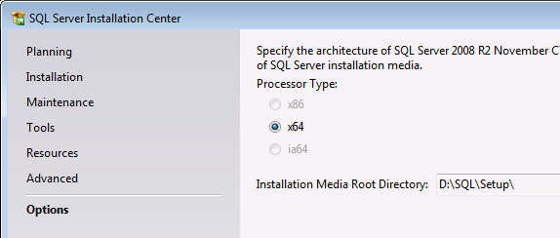
Figure 1. Setup screen: Selecting the appropriate platform
Go to Options and choose the correct platform.

Note: Before you start the upgrade, it is recommended that you script out replication. Those scripts will help you restore replication in case of total upgrade failure.

- After the upgrade is complete, if you are upgrading the Distributor, back up the master, msdb, and distribution databases. If you are upgrading the Publisher, back up the master, msdb, and replicated databases.
- Remove the instance of the 32-bit edition of SQL Server 2008 from the server. For more information, see How to uninstall an instance of SQL Server 2008.
- Install the 64-bit edition of SQL Server 2008. Ideally you may want to install it into the same folder from the previous installation. This will simplify maintenance of the server after the databases from the previous configuration are restored. (SQL Server 2008 Setup allows you to define the path where your databases will reside.)
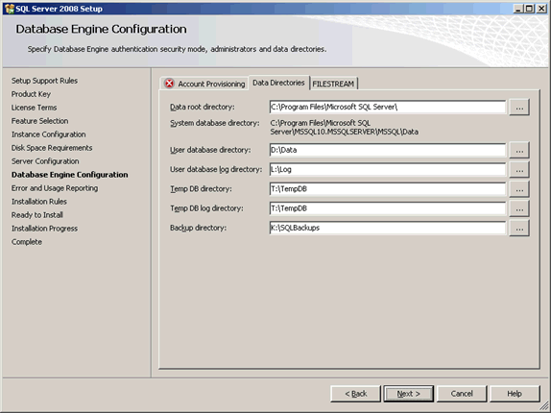
Figure 2. Setup screen: Defining the path for the databases

- Restore the master database from backup.
Follow these steps (although these steps are well documented in SQL Server Books Online, we will want to go through all of them here anyway):
  - Start SQL Server in single user mode using the –m parameter.
  - If the model database appears in the same folder as in the previous installation, the SQL Server service will start normally, and you can proceed to the next step. Otherwise the SQL service will fail to start. You should always check the error log for any errors, even if it looks like everything is running normally. For example, if SQL Server cannot find the model database, it will post the following message into the error log before it shuts down: "FCB::Open failed: Could not open file D:\Base\Model.mdf". The same message is written if SQL Server cannot find tempdb.
  - Restore master by using SQL Server Management Studio and connecting as an administrator with the following command:

RESTORE DATABASE master FROM DISK='E:\SQLDATA_OLD\BACKUP\MSSQL\BACKUP\master2000' WITH REPLACE
  - Before you restart SQL Server, ensure that the model database is placed in the same path as it was in the initial configuration. If not, follow these additional steps:
Restart SQL Server with the following trace flags: –m –f –T3608.

From the command prompt in Windows®, run: NET START MSSQL$instancename /m /f /T3608

To find the path of the system databases files, use the following query.

SELECT name,filename FROM sys.sysdatabases

or

SELECT name, physical_name AS CurrentLocation, state_desc
FROM sys.master_files

Create the folder and specify a path that matches the path in which the folder is stored in master. Copy model.mdf and model.ldf into this location.
Later you can move the model database into the new location so that all the databases are in the same data folder, which will help reduce database management complexity. For more information, see http://support.microsoft.com/kb/224071/en-us or Moving System Databases (http://msdn.microsoft.com/en-us/library/ms345408.aspx) in SQL Server Books Online.

  - Restart SQL Server without trace flags.
- Restore msdb, the distribution database for the Distributor, and the published databases on the Publisher. Because you are installing system databases over the existing ones, you must use the WITH REPLACE clause.
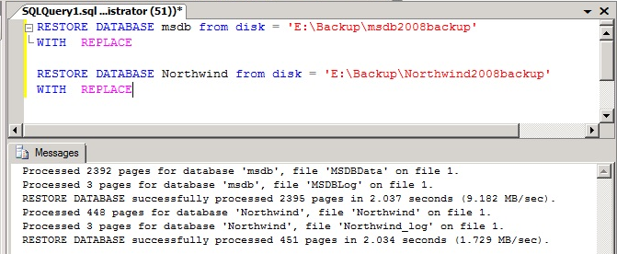
Figure 3. Published and master databases restored on the Publisher

When you restore distribution database, you will see that in addition to restoration, some replication configuration scripts are executed.

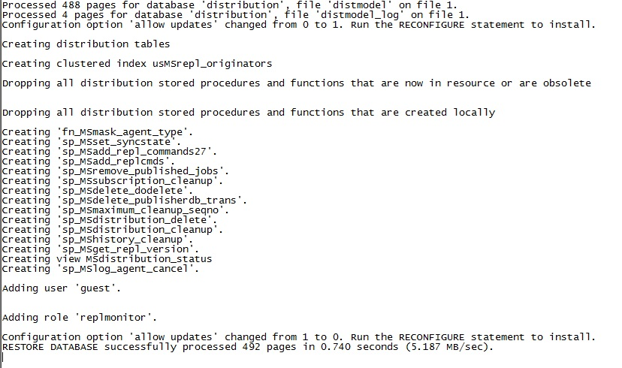
Figure 4. Restoration of the distribution database

- After everything is restored successfully, check the status of the SQL Server Agent jobs related to replication.
It is possible the Log Reader subsystem may fail to load.
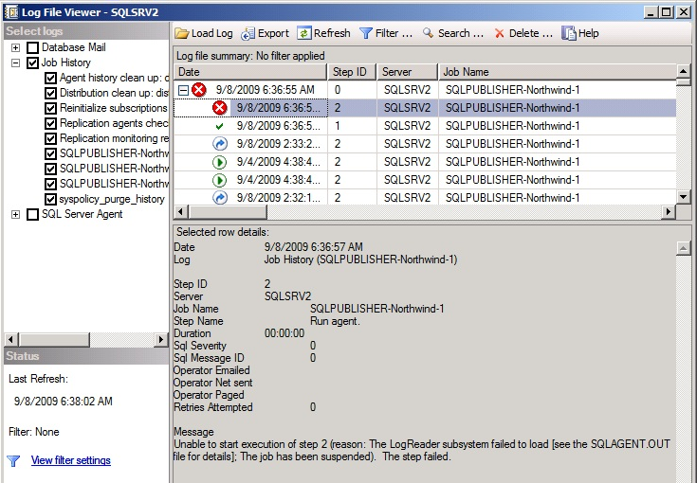
Figure 5. Log Reader failed to load
The paths to the SQL Server Agent subsystem DLLs are stored in the msdb.dbo.syssubsystems table in the msdb database. In the case of this example, after the msdb database was restored, the stored locations didn’t correspond to the current locations of the binaries for the installed instance of SQL Server 2008. For more information about this error, see http://support.microsoft.com/kb/914171.
To resolve this situation, we created and ran the script described in the next step.
- To get the Log Reader Agent running, execute the following script.

use msdb
go
delete from msdb.dbo.syssubsystems
exec msdb.dbo.sp_verify_subsystems 1
go

Ensure that SQL Server Agent starts.

- After you ensure that SQL Server Agent successfully starts, verify that all of the other jobs were successfully restored.

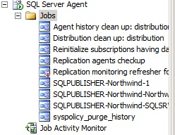
Figure 6. Jobs restored on the Distributor

- Although the agent starts, you will see that the replication does not work yet.
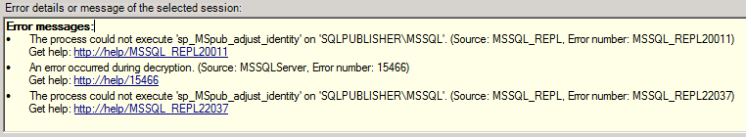
Figure 7. Replication failure

This failure occurs because after the new Distribution server was set up, the previous security configuration was not re-created on the new server. To address the issue, regenerate the Service Master Key (SMK) and update security properties such as password for distributor login. For more information about SMKs, see this Microsoft SQL Server Tips and Tricks blog entry (http://blogs.msdn.com/sqlserverfaq/archive/2008/07/16/regeneration-of-the-master-key-fails-when-we-try-to-take-the-backup-of-the-original-database-and-restore-on-other-instance-of-sql-server-on-other-machine.aspx) and Service Master Key (http://technet.microsoft.com/en-us/library/ms189060.aspx) in SQL Server Books Online.

Note: When you regenerate theSMK, you lose the linked server login passwords and the credential secrets (http://blogs.msdn.com/lcris/archive/2007/11/14/sql-server-2005-how-to-recover-when-the-service-master-key-smk-is-not-accessible.aspx). However, you need to take some additional steps to fully restore this information; the old passwords and logins won’t work with the new SMK. In our experience, it is not enough to change linked server login passwords. Our solution was to assign a different user with a different password and then change it back to the original user and password.

    - Force SMK regeneration by executing the following.

ALTER SERVICE MASTER KEY force REGENERATE;
GO

    - Change the password for the Distributor_Admin login.
    - Update the password in the Distributor Properties.
    - Restart the SQL Server services.

- Replication should now be running. You can test it by executing the transaction on your Publisher server. If your upgrade was successful, the transaction will be delivered to the Subscriber.

Publisher and Distributor on a Windows Server 2003 x64 Cluster

The process of upgrading the Publisher and Distributer from a clustered 32-bit edition of SQL Server 2000 to the 64-bit edition of SQL Server 2008 is more complicated than the process of upgrading in a stand-alone server scenario. The main difficult is that an in-place upgrade of the cluster from the 32-bit edition of SQL Server 2000 to the 32-bit edition of SQL Server 2008 on Windows Server 2003 x64 is not supported.
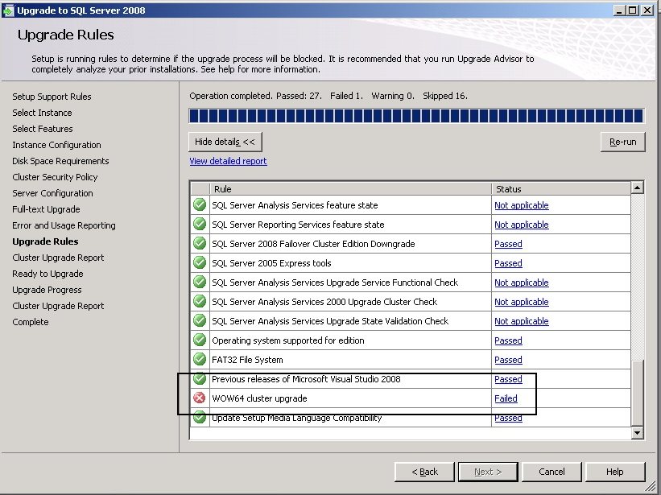
Figure 8: Failure of in-place upgrade of SQL Server 2000 SP4
However, we discovered a way to work around this limitation:
- Back up the system and user databases of the clustered 32-bit edition of SQL Server 2000.
- Prepare a stand-alone installation of the 32-bit edition of SQL Server 2000 with the same server and instance name as the clustered server. You may want to use a virtual server environment and setup server that is not part of your production Windows domain.
- Restore the system and user databases on the stand-alone server.
- Perform an in-place upgrade to the installation of the 32-bit edition of SQL Server 2008. This will upgrade the system and user databases.
- Back up the upgraded databases.
- Install a SQL Server 2008 64-bit cluster. (Note: Again, the new cluster should have the same name as it did in SQL Server 2000.)
- Restore the upgraded databases on the new cluster.

Note: We were testing the configuration with the transactional push replication. Therefore all replication agents were working in this configuration on the distribution server. However, the approach for migrating different transactional replication configuration would be similar to what we describe here.

The processes of restoring system and user databases and of starting replication are the same in this scenario as they are for the stand-alone scenario.

Conclusion

Working on this project, we proved that it is absolutely possible to satisfy a customer’s request and execute an upgrade from the 32-bit edition of SQL Server 2000 with SP4 to the 64-bit edition of SQL Server 2008 running on Windows Server 2003. Because this is a very challenging and complex migration, take the following considerations into account:
- If you have the flexibility to reinitialize or rebuild replication, you should take a backup of the user databases on the servers, perform a clean installation, and then set up replication again.
- If you cannot reinitialize or rebuild replication, follow the approach described above and test your migration thoroughly. Consider testing your migration scenario in a lab environment before you try it in production, in order to minimize risks and downtime.

